

# 

### Semester Two Examination, 2016

### Question/Answer Booklet

# MATHEMATICS

**APPLICATIONS**

**UNITS 1 AND 2**

## Section One:

## Calculator-free

**Your name**

**Your teacher (circle one)** Foxton Hanna Hill Scorer Wallace

## Time allowed for this section

Reading time before commencing work: five minutes

Working time for section: fifty minutes

## Materials required/recommended for this section

***To be provided by the supervisor***

This Question/Answer Booklet

Formula Sheet

***To be provided by the candidate***

Standard items: pens (blue/black preferred), pencils (including coloured), sharpener, correction fluid/tape, eraser, ruler, highlighters

Special items: nil

## Important note to candidates

No other items may be taken into the examination room. It is **your** responsibility to ensure that you do not have any unauthorised notes or other items of a non-personal nature in the examination room. If you have any unauthorised material with you, hand it to the supervisor **before** reading any further.

## Structure of this paper

|  |  |  |  |  |  |
| --- | --- | --- | --- | --- | --- |
| Section | Number of questions available | Number of questions to be answered | Working  time (minutes) | Marks available | Percentage of exam |
| Section One:  Calculator-free | 7 | 7 | 50 | 51 | 35 |
| Section Two:  Calculator-assumed | 13 | 13 | 100 | 99 | 65 |
|  | | | **Total** | 150 | 100 |

## Instructions to candidates

1. The rules for the conduct of examinations are detailed in the school handbook. Sitting this examination implies that you agree to abide by these rules.

2. Write your answers in this Question/Answer Booklet.

3. You must be careful to confine your response to the specific question asked and to follow any instructions that are specified to a particular question.

4. Spare pages are included at the end of this booklet. They can be used for planning your responses and/or as additional space if required to continue an answer.

* Planning: If you use the spare pages for planning, indicate this clearly at the top of the page.
* Continuing an answer: If you need to use the space to continue an answer, indicate in the original answer space where the answer is continued, i.e. give the page number. Fill in the number of the question that you are continuing to answer at the top of the page.

5. **Show** **all your working clearly**. Your working should be in sufficient detail to allow your answers to be checked readily and for marks to be awarded for reasoning. Incorrect answers given without supporting reasoning cannot be allocated any marks. For any question or part question worth more than two marks, valid working or justification is required to receive full marks. If you repeat any question, ensure that you cancel the answer you do not wish to have marked.

6. It is recommended that you **do not use pencil**, except in diagrams.

7. The Formula Sheet is **not** to be handed in with your Question/Booklet.

Section One: Calculator-free 35% (51 Marks)

This section has**seven (****7)** questions. Answer **all** questions. Write your answers in the spaces provided.

Working time for this section is 50 minutes.

Question 1 (6 marks)

(a) If $a=10$, $t=2$ and $u=5.5$, determine the value of $s$, where $s=ut+\frac{1}{2}at^{2}$. (2 marks)

(b) If $m=\frac{a+b+c}{3}$, determine the value of $a$ when $b=10$, $c=13$ and $m=9$. (2 marks)

(c) If $d=\sqrt{b^{2}-4ac}$, determine the value of $a$ when $b=3$, $c=-1$ and $d=5$. (2 marks)

Question 2 (7 marks)

A group of 28 people gave a movie they had just watched together a rating of between one and five stars. Their star ratings are listed below:

|  |  |  |  |  |  |  |  |  |  |  |  |  |  |
| --- | --- | --- | --- | --- | --- | --- | --- | --- | --- | --- | --- | --- | --- |
| 2 | 4 | 4 | 2 | 2 | 1 | 4 | 4 | 4 | 2 | 4 | 3 | 3 | 1 |
| 5 | 2 | 4 | 5 | 2 | 4 | 4 | 2 | 2 | 3 | 2 | 5 | 4 | 3 |

(a) Explain why this type of data is considered categorical and choose **one** more word to further describe the data from the following list: nominal, ordinal, discrete, continuous.

(2 marks)

(b) Complete the frequency table below for the ratings. (2 marks)

|  |  |  |
| --- | --- | --- |
| Rating | Tally | Frequency |
| 1 |  |  |
| 2 |  |  |
| 3 |  |  |
| 4 |  |  |
| 5 |  |  |

(c) Display the ratings as a bar graph using the grid below. (3 marks)

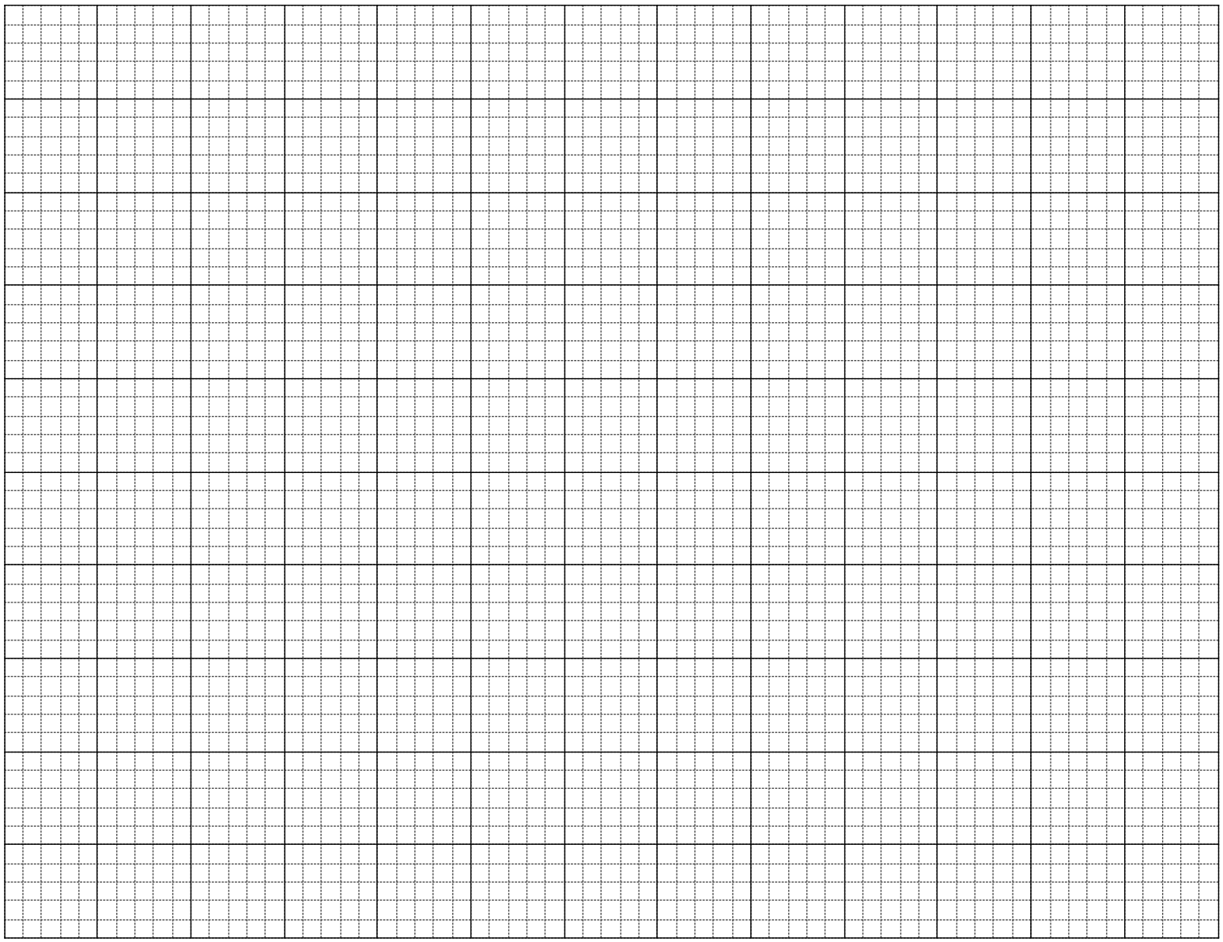

Question 3 (7 marks)

Consider the matrices $A=\left[\begin{matrix}2 & 1 \\ -1 & 3\end{matrix}\right]$, $B=\left[\begin{matrix}5 \\ -3\end{matrix}\right]$, $C=\left[\begin{matrix}3 & -2 \\ 1 & 0\end{matrix}\right]$ and $D=[\begin{matrix}6 & 2\end{matrix}]$.

(a) Calculate, where possible, the following. If not possible, explain why.

(i) $5C$. (1 mark)

(ii) $2D+3B$. (1 mark)

(iii) $A-C$. (1 mark)

(iv) $AC$. (2 marks)

(b) Determine the value of $x$ if $\left[\begin{matrix}2 & -2 & x\end{matrix}\right]×\left[\begin{matrix}x \\ 4 \\ 3\end{matrix}\right]=[4x]$. (2 marks)

Question 4 (9 marks)

The graph below, developed by Monsieur Le Beau, can be used to determine if a cat is old or young in relation to human age. For example, a one-year-old cat ($c=1$) will have the equivalent age of a fifteen-year-old human ($h=15$).

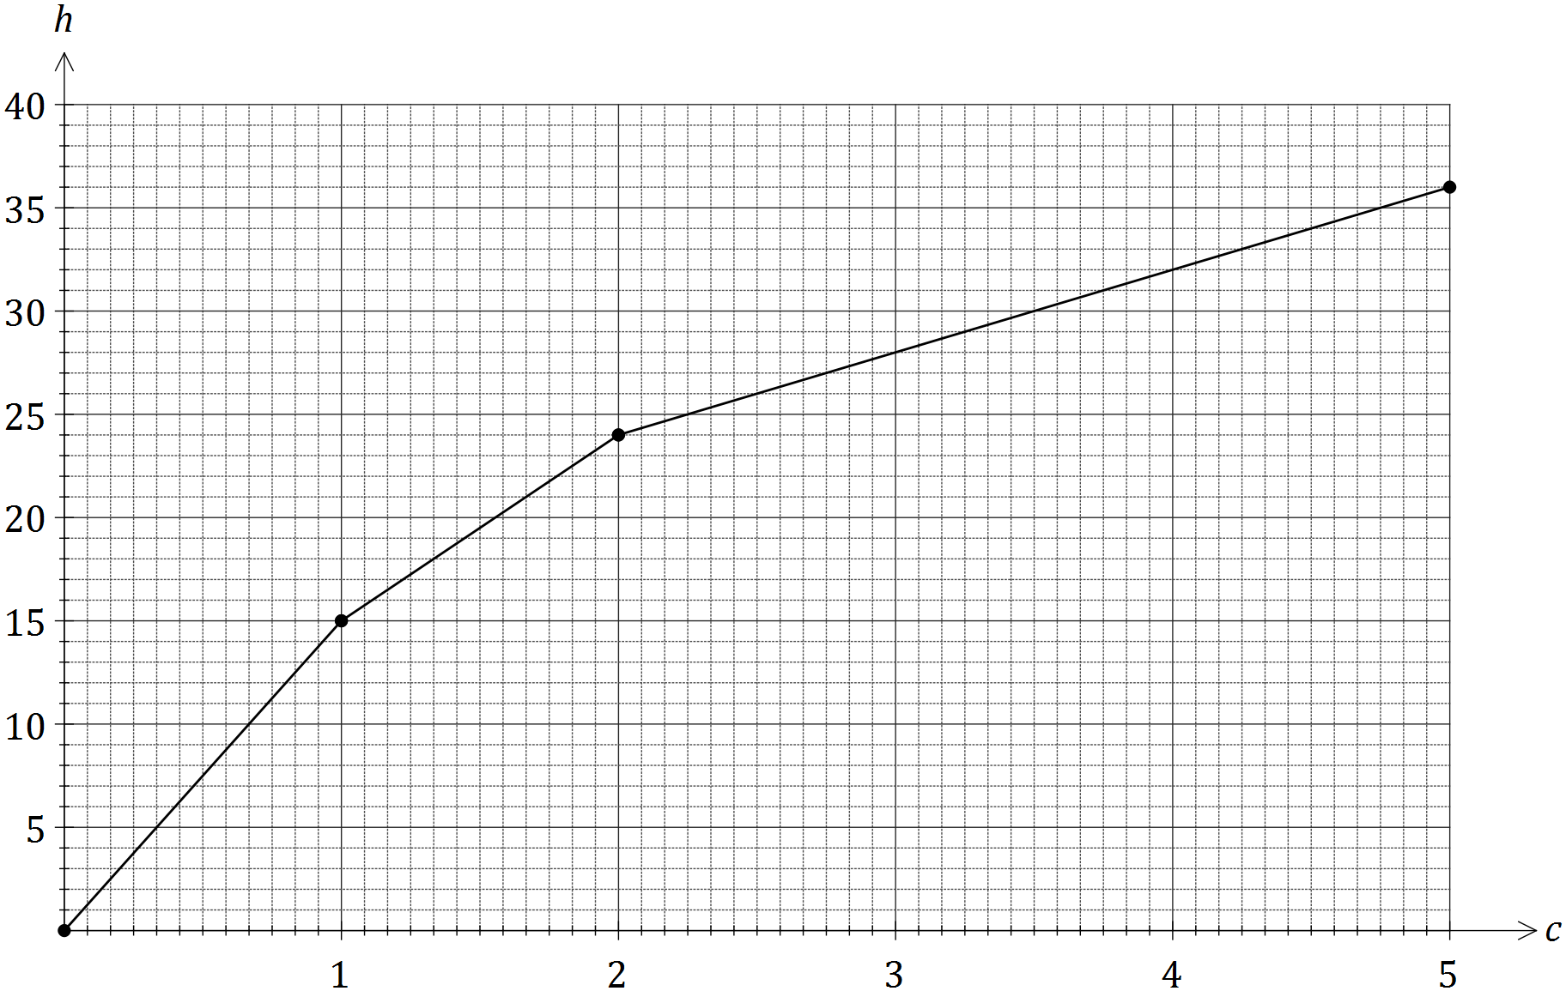

(a) Use the graph to determine

(i) the equivalent human age of a cat that is four and a half years old. (1 mark)

(ii) the age of a cat with an equivalent human age of 18 years. (1 mark)

(b) Calculate the gradient of the line for cats that are between one and two years old, and interpret what its value means in this context. (2 marks)

(c) Determine the equation of the line for cats that are two years or older. (3 marks)

(d) Use your equation from (c) to determine the age of a cat with an equivalent human age of 60 years. (2 marks)

Question 5 (9 marks)

The number of telephone calls answered per hour in an office over a survey period of 22 hours is shown in the table below.

|  |  |  |  |  |  |  |  |
| --- | --- | --- | --- | --- | --- | --- | --- |
| Number of calls | 0 | 1 | 2 | 3 | 4 | 5 | 6 |
| Frequency | 1 | 4 | 6 | 5 | 3 | 1 | 2 |

(a) Construct a boxplot for this data. (3 marks)



(b) Use the boxplot to explain whether the mean number of telephone calls answered per hour would be higher than, lower than or the same as, the median. (2 marks)

The box plot for telephone calls over a different 12-hour period is given below



(c) Give a set of 11 scores that is consistent with this box plot, with 6 as its only mode.

(2 marks)

1. Give a set of 11 scores with a mean of 6 that is consistent with this box plot.

(2 marks)

Question 6 (6 marks)

The table below shows the number of overseas (O) and local (L) letters sent by a company over a period of five consecutive days.

|  |  |  |  |  |  |  |  |  |  |
| --- | --- | --- | --- | --- | --- | --- | --- | --- | --- |
| *Mon* | | *Tue* | | *Wed* | | *Thu* | | *Fri* | |
| O | L | O | L | O | L | O | L | O | L |
| 0 | 8 | 2 | 5 | 1 | 10 | 5 | 15 | 3 | 6 |

(a) Represent this information in a $2×5$ matrix $M$. (2 marks)

(b) The cost of sending a local letter is $1 and an overseas letter is $3. Show this information in matrix $C$ that can be multiplied by matrix $M$ to create a meaningful result. (1 mark)

(c) Calculate the product of the two matrices from (a) and (b) and explain what information this matrix shows. (2 marks)

(d) Multiplying your answer to (c) by another matrix $T$ will result in a $1×1$ matrix that represents the total cost of sending the letters over the five-day period. Determine a suitable matrix $T$. (1 mark)

Question 7 (7 marks)

A prism, with a right-triangular cross-section and square base, has dimensions as shown in the diagram below.

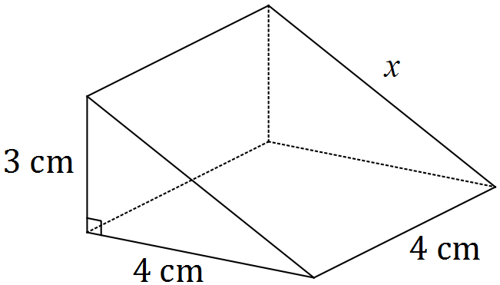

(a) Use Pythagoras' Theorem to show that the sloping edge marked $x$ is 5 cm long. (1 mark)

(b) Calculate the total surface area of the prism. (2 marks)

(c) Calculate the volume of the prism. (1 mark)

(d) The prism is a $1:n$ scale model of a larger solid that has a square base measuring 28 cm by 28 cm.

(i) State the value of the scale factor $n$. (1 mark)

(ii) The total surface area of the larger solid can be determined by multiplying your answer to (b) by $k$. State the value of $k$. (1 mark)

(ii) Write down a calculation that would give the volume of the larger solid, but do not evaluate it. (1 mark)

Additional working space

Question number: _________

© 2016 WA Exam Papers. Kennedy Baptist College has a non-exclusive licence to copy and communicate this paper for non-commercial, educational use within the school. No other copying, communication or use is permitted without the express written permission of WA Exam Papers.